GREATER BRIDGEPORT TRANSIT BUS RELIABILITY STUDY
Statistical Quality Control Analysis Using DMAIC Six Sigma
Group 2 | SQC Term Project
Route: Park Ave @ Linden Ave, Bridgeport, CT
Data Collection Period: February 16 – March 6, 2026
Course: Statistical Quality Control
Spring 2026
Jack Mindek (Team Leader) – Timelines & deliverables
Ama Abrafi Acheampong (Data Collector & Analyst) – Statistical Analysis & Charts
Pavan Kalyan (Data Manager) – Spreadsheet Organization
Elizabeth Kankam (Analyst) – Research & Chart preparation
Joaquin Gonzalez Mendoza – Report formatting

Table of Contents
1.1 Background 2
1.2 Project Objectives 3
1.3 DMAIC Framework Application 3
2. Data Collection and Methodology (Measure Phase) 4
2.1 Data Collection Protocol 4
2.2 Dataset Overview 4
2.3 Key Measurements 5
3. Statistical Analysis Results (Analyze Phase) 6
3.a Descriptive Statistics Summary 6
3.b & 3.c On-Time Performance Rates 10
3.d Peak vs. Off-Peak Comparison (Stratified Analysis) 11
3.e Average Deviation by Day of Week 12
3.f Weather Impact Analysis 13
4. Improve Phase 14
5. CONTROL 16
Conclusion 17
Challenges: 18
Opportunities for Future Improvement: 18
Most Effective Learning Tools: 19

LIST OF FIGURES

1 Dispatch to Arrival Value Stream Map 8
2ROOT CAUSE ANALYSIS DIAGRAM 11
3 ON-TIME PERFORMANCE COMPARISON 13
4 ROADMAP TO IMPROVEMENT 17
5 ROADMAP TO SIGMA IMPROVEMENT 17
6 Control Measures for Sustaining Improvements 19

LIST OF TABLES

1DATASET OVERVIEW 6
2 DESCRIPTIVE STATISTICS 8
3 COMMON CAUSES VS. ASSIGNABLE CAUSES 11
4 ON TIME PERFORMANCE RATE 12
5 PEAK VS. OFF-PEAK COMPARISON 13
6 AVERAGE DEVIATION BY TIME OF DAY 14
7 WEATHER IMPACT ANALYSIS 15

1.1 Background
Public transit reliability is a critical service quality metric that directly impacts ridership, community trust, and the operational effectiveness of transit authorities.
The American Public Transportation Association (2010) defines service reliability using adherence to scheduled time as a baseline.
According to industry standards set by the Federal Transit Administration (2013), the on-time arrival for a bus should be in an acceptable window of early and late arrivals. The current system conforms to this standard.
Conforming to set standards, GBT’s operational standard defines on-time performance as arrivals with no more than 5 minutes of the published schedule (GBT, 2022).
Our team adopted a stricter project standard of ±3 minutes to evaluate whether the route meets higher service expectations aligned with modern Six Sigma quality benchmarks.

1.2 Project Objectives
- Quantify bus arrival performance at Park Ave @ Linden Ave using statistical methods
- Compare on-time rates under GBT’s ±5-minute standard and our ±3-minute project standard
- Identify stratified performance differences between peak and off-peak periods
- Assess the impact of weather conditions and day of the week on arrival deviations
- Apply I-MR control charts to evaluate statistical process control
- Conduct process capability analysis (Cp, Cpk) to benchmark against specification limits
- Develop actionable recommendations through the DMAIC framework.

1.3 DMAIC Framework Application
This project follows the Six Sigma DMAIC methodology: Define (project scope, GBT route, and KPIs), Measure (90 observations collected by team members over 3 weeks), Analyze (statistical tools applied including control charts and capability analysis), Improve (root causes identified, recommendations developed), and Control (control limits established for ongoing monitoring) (Montgomery, 2019).

2. Data Collection and Methodology (Measure Phase)

2.1 Data Collection Protocol
Team members stationed at the Park Avenue and Linden Avenue bus stop recorded actual bus arrival times against GBT’s published schedule. Observations were made across multiple time slots representing both peak hours (7:30 AM, 8:00 AM, 8:30 AM) and off-peak hours (11:00 AM, 1:30 PM, 7:00 PM) from Monday through Friday across three weeks. The deviation for each arrival was computed in minutes, where negative values denote early arrivals and positive values denote late arrivals.

2.2 Dataset Overview
Parameter | Detail
Route | Park Ave @ Linden Ave, Bridgeport, CT
Data Collection Period | Feb 16 – Mar 6, 2026 (3 weeks)
Total Observations | 90
Valid Observations | 88 (2 trips canceled)
Days Covered | Monday through Friday
Peak Time Slots | 7:30 AM, 8:00 AM, 8:30 AM
Off-Peak Time Slots | 11:00 AM, 1:30 PM, 7:00 PM
Measurement Unit | Minutes Early/Late (negative = early)
Project On-Time Standard | ±3 minutes
GBT On-Time Standard | ±5 minutes
1DATASET OVERVIEW

2.3 Key Measurements
Two trips were canceled on February 23, 2026, during a snow event and are excluded from quantitative analysis but are noted as service disruptions. The remaining 88 observations span a range of −25 to +23 minutes deviation (with the −5 being the most negative recorded), weather conditions from clear through heavy snow, and all five weekdays.
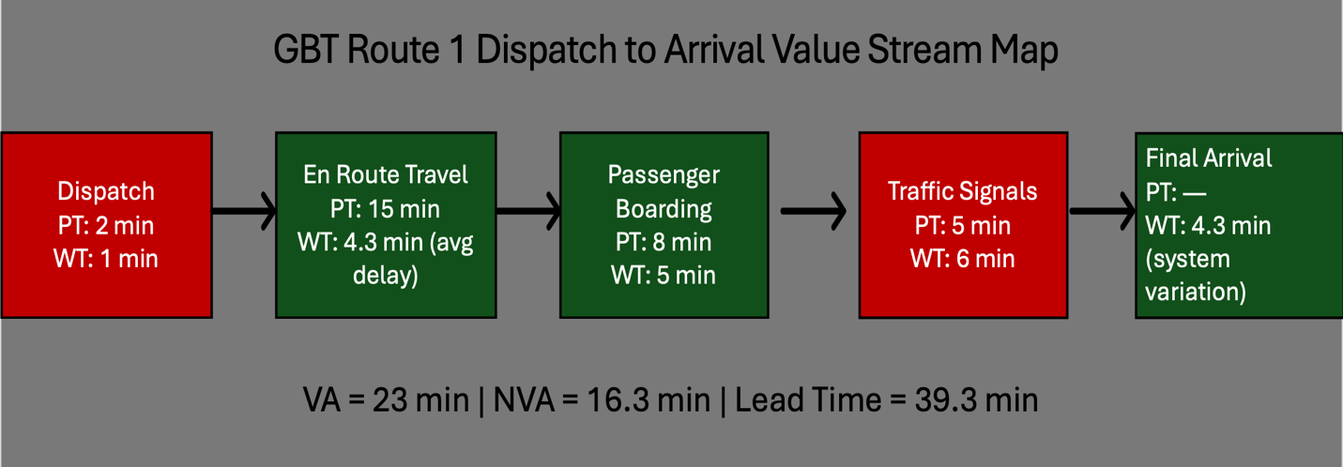
1 Dispatch to Arrival Value Stream Map

Value-Added (VA) time is time spent doing work the customer is willing to pay for; in our case, time the bus is actively transporting passengers or completing tasks they value.
Non-Value-Added (NVA) Time does not add value from the customer’s perspective. It includes waiting, delays, or stops that don’t move the customer closer to their destination.
The value stream map, developed using 88 collected data points, indicates that the bus arrival process is significantly impacted by non-value-added time, particularly delays due to traffic signals, passenger boarding, and overall system variability. The average delay of approximately 4.3 minutes, along with extreme values exceeding 20 minutes, highlights process instability and supports findings from control chart analysis that the system is not in statistical control.

3. Statistical Analysis Results (Analyze Phase)

3.a Descriptive Statistics Summary
The following table presents the complete descriptive statistics for the 88 valid bus arrival deviation observations (in minutes):
Statistic | Value | Interpretation
Count (Valid) | 88 | Excluding 2 canceled
Mean Deviation | +4.08 min | Buses run 4 min late on avg.
Median Deviation | +3.0 min | Half of trips > 3 min late
Std Deviation | 5.78 min | High variability
Minimum | −5 min | Maximum early arrival
Maximum | +23 min | Worst late arrival
Range | 28 min | Wide spread
Q1 (25th pct) | −1.0 min | 25% of trips early/on-time
Q3 (75th pct) | +7.0 min | 75% threshold
IQR | 8.0 min | Middle 50% spread
% Early (< 0) | 28.4% | 25 trips arrived early
% On Time (= 0) | 3.4% | 3 trips exactly on schedule
% Late (> 0) | 68.2% | Majority arrive late
2 DESCRIPTIVE STATISTICS
The distribution is right-skewed (mean > median), indicating that while most trips are moderately late, a subset of severely late trips (>15 min) pulls the mean upward. The high standard deviation (5.78 min) relative to the ±5 min specification window underscores the process variability.
To assess process capability, the Cpk index was calculated:
$$Cpk=min⁡(Cpu,Cpl$$
$$Cpu=\frac{USL-μ}{3σ} \\ Cpl=\frac{μ-LSL}{3σ}$$
$$Cpu=\frac{3-4.08}{3(5.78)}=\frac{-1.08}{17.34}=-0.06$$
$$Cpl=\frac{4.08-(-3)}{3(5.78)}=\frac{7.08}{17.34}=0.41$$
$$Cpk=min⁡(Cpu,Cpl)$$
$$Cpk=\min\left(-0.06,0.41\right)=-0.06$$
$$\boxed{Cpk=-0.06}$$
The negative Cpk value suggests that the process is not capable of meeting our project's ±3-minute benchmark. To be more specific, the process mean exceeds the upper specification limit, meaning buses are consistently arriving late. Additionally, the large standard deviation suggests significant variability in arrival times.

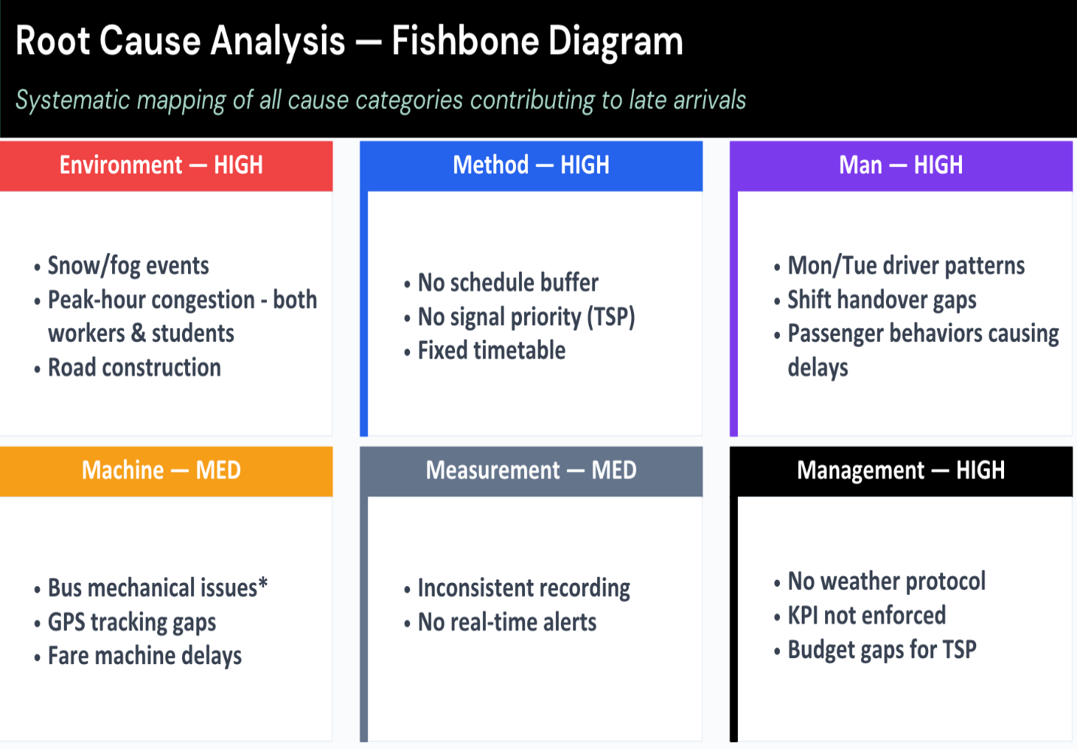
2ROOT CAUSE ANALYSIS DIAGRAM

Category | Common Causes | Assignable Causes
Environmental | Peak Hour Congestion | Snow/fog, Road construction
Machine | - | Bus mechanical problems, GPS tracking gaps, Fare machine delays
Method | No schedule buffer, No signal priority, Fixed timetable | -
Man | Driver patterns, Passenger behaviors | Shift handover gaps
Measurement | - | Inconsistent/unrealistic recordings, No real-time alerts
Management | - | No weather protocol, KPI not enforced, Budget gaps for TSP
3 COMMON CAUSES VS. ASSIGNABLE CAUSES
Our root cause analysis suggests that the variations may be influenced by common causes and assignable causes, which suggests the problem is twofold: The process is not centered (biased toward lateness)

3.b & 3.c On-Time Performance Rates
Two on-time standards were applied to evaluate performance using the collected data:
Standard | On-Time | Late | Early | Total | On-Time Rate
Project (±3 min) | 43 | 42 | 3 | 88 | 48.9%
GBT (±5 min) | 57 | 31 | N/A | 88 | 64.8%
4 ON TIME PERFORMANCE RATE
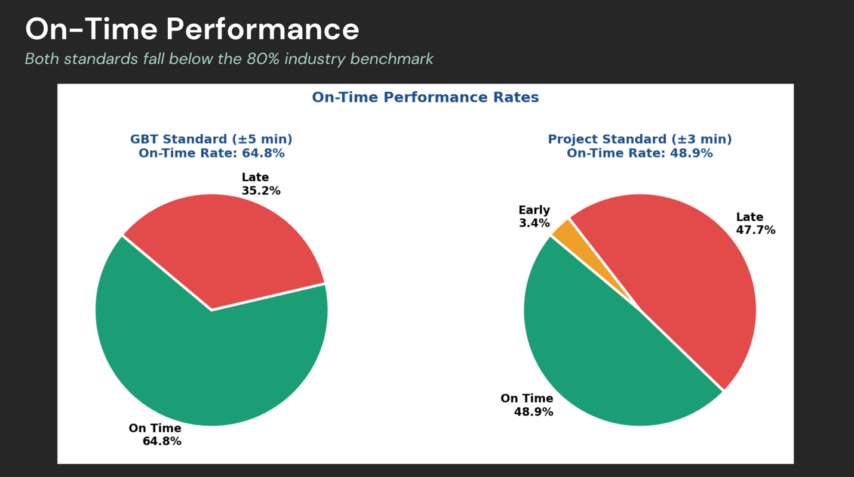
3 ON-TIME PERFORMANCE COMPARISON
Under the GBT standard (±5 min), the route achieves a 64.8% on-time rate, meaning more than one-third of trips fail to meet the agency’s own benchmark. Under our stricter ±3-minute project standard using the collected data, performance drops to 48.9%, which suggests that the majority of trips do not meet this threshold. Both figures fall significantly below the industry benchmark of 80% on-time performance that many transit agencies target.

3.d Peak vs. Off-Peak Comparison (Stratified Analysis)
Stratifying the data by period reveals a significant performance gap between peak and off-peak service windows:
Metric | Peak Period | Off-Peak Period | Difference
Observations | 44 | 44 | —
Mean Delay (min) | 5.07 | 3.09 | +1.98 min
Std Deviation (min) | 6.53 | 4.85 | +1.68 min
On-Time % (±3 min) | 34.1% | 63.6% | −29.5%
On-Time % (±5 min GBT) | 54.5% | 75.0% | −20.5%
# Late Trips | 20 | 11 | +9
5 PEAK VS. OFF-PEAK COMPARISON
Peak-hour service shows a 64% higher mean delay compared to off-peak (5.07 vs. 3.09 minutes). The on-time rate under the GBT standard drops from 75.0% (off-peak) to only 54.5% (peak), a 20.5 percentage point gap. This confirms that morning rush hour traffic congestion is a primary driver of service unreliability. This finding aligns with the DMAIC Analyze phase, identifying peak-hour traffic as a critical X (input variable) affecting the Y (on-time performance).

3.e Average Deviation by Day of Week
Day | Count | Mean Delay | Std Dev | GBT On-Time % | Assessment
Monday | 16 | 6.50 min | 7.12 min | 62.5% | Poor
Tuesday | 18 | 7.22 min | 6.13 min | 50.0% | Worst
Wednesday | 18 | 1.61 min | 4.31 min | 77.8% | Best
Thursday | 18 | 3.67 min | 5.12 min | 55.6% | Fair
Friday | 18 | 1.67 min | 3.87 min | 77.8% | Best
6 AVERAGE DEVIATION BY TIME OF DAY
Monday and Tuesday show the worst performance, with mean delays of 6.50 and 7.22 minutes respectively, and GBT on-time rates of 62.5% and 50.0%. No day meets the 80% industry benchmark, though Wednesday and Friday come closest at 77.8%. The February 23 snow event (Monday) contributed to Monday’s poor performance, while Tuesday’s consistent underperformance across both weeks suggests structural factors such as post-weekend traffic build-up.

3.f Weather Impact Analysis
Weather conditions proved to be a statistically significant factor in arrival deviations:
Weather Condition | Count | Mean Delay | GBT On-Time % | Impact Level
Clear | 8 | 1.38 min | 87.5% | Low
Partly Cloudy | 17 | 1.94 min | 82.4% | Low
Cloudy | 53 | 4.43 min | 64.2% | Moderate
Rain | 4 | 4.50 min | 75.0% | Moderate
Fog | 3 | 6.67 min | 33.3% | High
Snow | 2 | 12.50 min | 0.0% | Severe
Snow Showers | 1 | 17.00 min | 0.0% | Severe
7 WEATHER IMPACT ANALYSIS
Clear and partly cloudy conditions yield on-time rates above 80%, while snow and fog conditions produce 0% on-time rates with mean delays exceeding 12 minutes. The snow event on February 23 resulted in two trip cancellations and delays of 11–17 minutes. These findings suggest that GBT should implement weather-specific contingency protocols, particularly for winter precipitation events.

4. Improve Phase
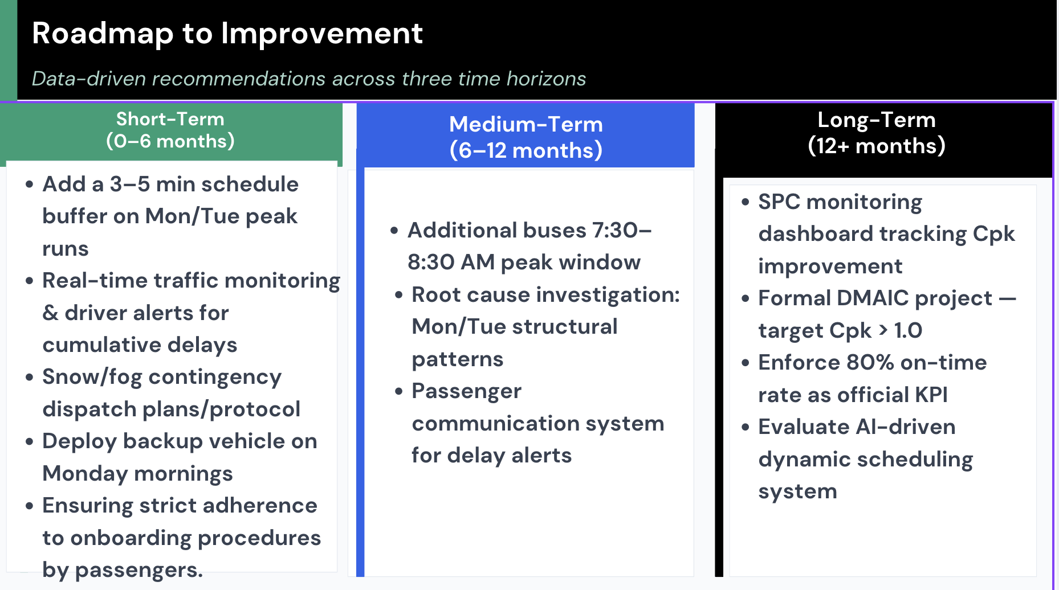
4 ROADMAP TO IMPROVEMENT
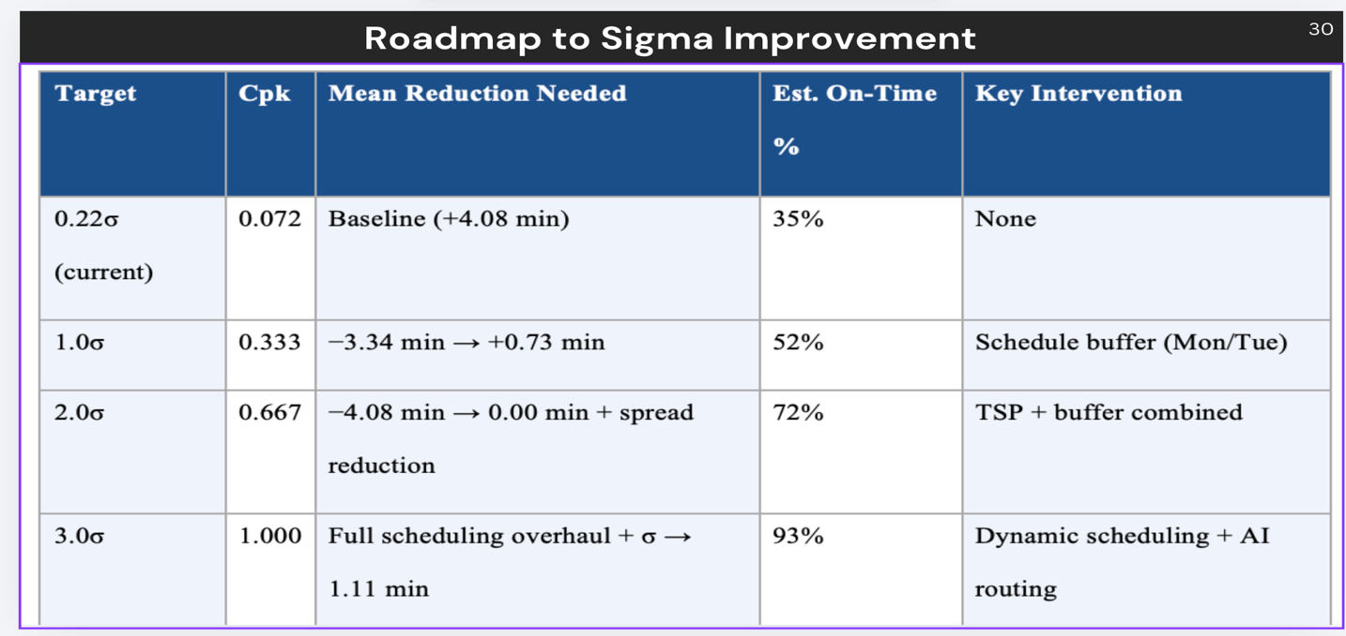
5 ROADMAP TO SIGMA IMPROVEMENT
For our improvement phase, we focused on Six Sigma tools to reduce variation and improve the capability of the process, while we focused on Lean principles to eliminate waste, such as non-value-added time, which we identified in our value stream map in Figure 1.
To achieve the target of ±3 minutes, these are our recommendations:
- Schedule Buffer: Revise bus schedules to better reflect realistic travel times while considering days and times that experience more congestion compared to others.
- Traffic Management Strategies: Identify high-delay routes and implement alternative routing where possible.
- Driver Training: Standardize driving practices to reduce variability in performance.
- Real-Time Monitoring: Use GPS tracking to monitor bus performance and make real-time adjustments.
- Segment Analysis: Separate peak and off-peak data to better understand and address variability sources.
- Additional buses: assigning more buses during peak windows to account for and reduce delay and congestion
- Enforce stricter KPIs: an 80% on-time rate as the official KPI.
- Statistical process monitoring, which involves dashboard tracking and Cpk improvement
- A formal DMAIC project with a Cpk greater than one
These improvements aim to both center the process (reduce lateness) and reduce variability, while reducing lead time and improving overall process flow.

CONTROL
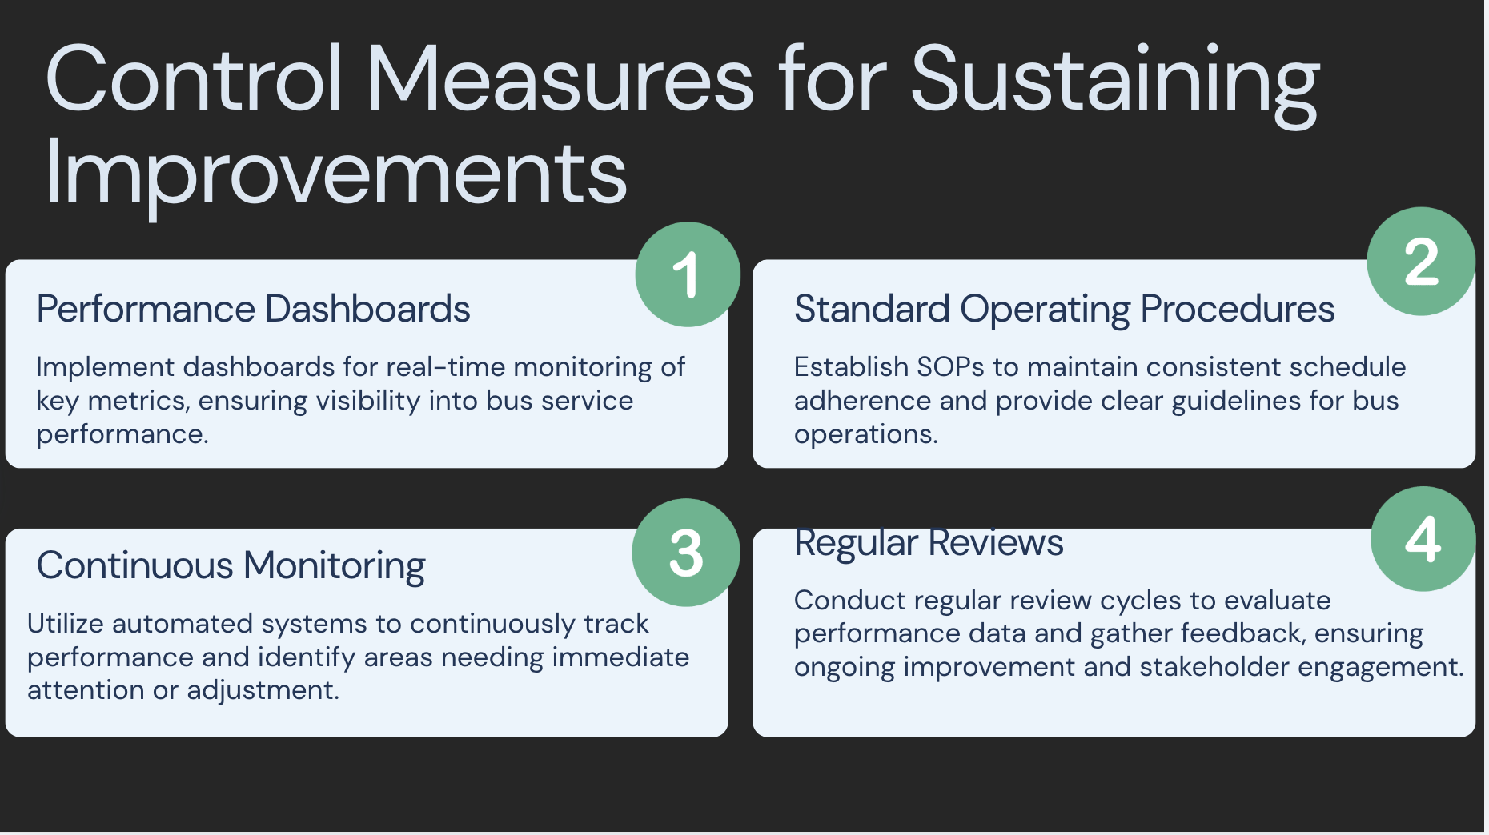
6 Control Measures for Sustaining Improvements
To hold the gain, ongoing monitoring is essential. The following control measures are recommended:
- Implement control charts (e.g., Individuals chart) to track arrival times over time
- Establish performance benchmarks for acceptable variation
- Continuously monitor for assignable causes and take corrective action
- Periodically recalculate process capability (Cpk) to ensure sustained improvement
Maintaining statistical control will ensure that the process remains stable and continues to meet the desired performance standards.

Conclusion
This project demonstrates how the DMAIC framework can be used to identify and address variability in public transportation systems. The analysis revealed that delays were not random but driven by identifiable factors such as traffic congestion, scheduling inefficiencies, and weather conditions.
By focusing on the “vital few” causes, the team developed targeted and realistic solutions that can significantly improve reliability. While the process is currently not capable based on Six Sigma standards, the proposed improvements provide a clear path toward achieving higher performance levels.

Challenges:
- Initial attempts to use AI-generated data were unsuccessful
- Inconsistencies between app data and real-time observations
- Focus on real-time data and variables suited for smaller datasets, such as Bus Number.
- The process is not statistically capable at present.
- Any improvements should bring the process to statistical control before reducing variation.
- More data collection would be needed to generalize conclusions for the entire Route 1

Opportunities for Future Improvement:
- Expand analysis to additional routes
- Incorporate bus-specific tracking data
- Conduct value stream mapping for deeper process insight
- Continue refining statistical models for better prediction accuracy

Most Effective Learning Tools:
- DMAIC Framework provided a structured approach to problem-solving
- ANOVA Testing helped identify statistically significant factors
- Regression Analysis quantified the impact of variables
- Pareto Charts identified the most critical causes
- Fishbone Diagram organized root cause categories
- Process Capability Analysis evaluated system performance
These tools allowed the team to move beyond assumptions and make data-driven decisions.

References
American Public Transportation Association. (2010). Bus rapid transit service design: Recommended practice(APTA BTS-BRT-RP-004-10). https://www.apta.com/wp-content/uploads/Standards_Documents/APTA-BTS-BRT-RP-004-10.pdf
Federal Transit Administration. (2013). Transit capacity and quality of service manual (3rd ed.). Transportation Research Board. https://doi.org/10.17226/24766
Greater Bridgeport Transit Authority. (2022, March 9). Title VI program update (on-time performance standards defined). https://gogbt.com/wp-content/uploads/GBT-Title-VI-Publication-MAR-2022-Final2-w-cover-and-appendices-2022-03-29.pdf
Montgomery, D. C. (2019). Introduction to statistical quality control (8th ed.). John Wiley & Sons.

